NAME: BHAGAVATHY M
REG NO: 2019504012
TITLE: MAKING LED BLINK USING RASPBERRY PI AND PYTHON
CODE:
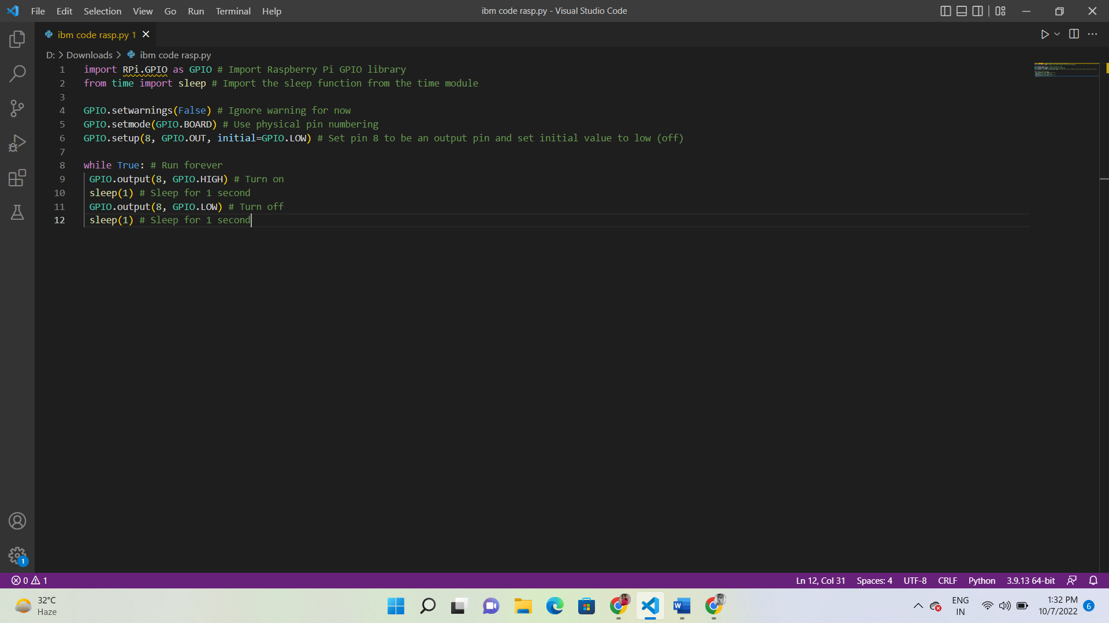
TITLE: MAKING TRAFFIC LIGHT USING RASPBERRY PI AND PYTHON
CODE:
